March 27, 2020
Dear Customer:
We hope this finds you, your family, your staff, patients and organizations well as we all deal with the current crisis of COVID-19. We recognize many of you are on the front line battling this virus with limited resources and doing it in an extraordinary way, for this, we at Hologic thank you for all that you are doing. As you are aware, at Hologic, we have always taken immense pride in being an unwavering partner with you in the fight against breast cancer. Now, however, we join you and the rest of the nation in fighting this new enemy in COVID-19.
These are unprecedented times in which the challenges we face are re-defined daily, requiring an equally unprecedented level of collaboration and support among us all.
For Hologic, that means looking for solutions that will make a difference on the lives of both clinicians and patients through innovation. In fact, Hologic recently received Emergency Use Authorization from the FDA for its high throughput COVID-19 test, which is being delivered to laboratories and hospitals across the country at this very moment. Additionally, many of you have engaged with our team who have fought for access to breast cancer screening and treatment in Washington over the past several years. That very team is actively engaged today, fighting for solutions to help hospitals and providers weather this storm, including the much-needed stimulus package that will help keep hospitals running.
While we are actively engaged in the battle against COVID-19, we cannot lose sight of the fact that breast cancer hasn’t slowed. Women will re-engage in preventive screening and, unfortunately, many will be diagnosed with breast cancer and require treatment in the coming months. With that in mind, we want to reassure you that we are here for you, as always, during good times and bad.
Please don’t hesitate to let us know what we can do to help you throughout this crisis and during the ultimate recovery period. You can always contact your local Hologic representative or reach out to our COVID19 Taskforce at: CovidTaskforceBSH@hologic.com
We will also post relevant information about our breast and skeletal health products and other helpful resources to our website at hologic.com/about/coronavirus-update/BSH.
As your trusted breast health and skeletal health partner, we remain committed to you and the patients you serve. We are greatly appreciative of all you are doing and want you to know we are by your side, as always, in this fight. We will remain here for you in the days, weeks and months that follow, no matter what.
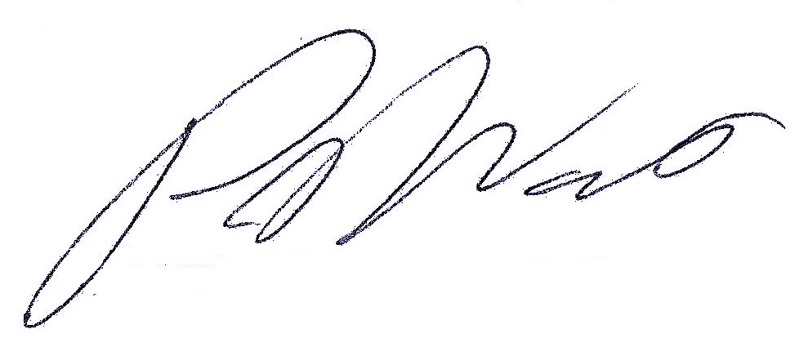
Sincerely,

Peter J. Valenti
Division President, Breast and Skeletal Health Solutions

